**PicoTones**

Group Members: Saumya Saini (200901)

Sandhya Narwade (200858)

Pallavi (200661)

Ideation

The PicoTones project aims to develop an interactive instrument that generates sound when keys are touched, utilizing an IR sensor to detect key movements, an Arduino for processing sensor input, and a speaker for sound output. A detailed system design has been created, incorporating the integration of the IR sensor, Arduino, and speaker into a functional piano. Connections and communication between the components have been defined, and considerations have been made for programming logic, wiring, and mounting arrangements. A functional prototype of the musical piano has been built, and Arduino code has been implemented to process IR sensor input, generate sound signals, and control speaker output.

Sensor

An IR sensor is employed to detect key presses or releases. By emitting infrared radiation and measuring the reflected radiation, the IR sensor can identify changes in reflection caused by the interruption of the IR beam when a finger is kept above the sensor. This allows the sensor to determine which key has been pressed or released based on the detected change in reflection.

Actuator

The speaker acts as an actuator by producing sound in response to the input from the IR sensor and the processing done by the Arduino. When the Arduino processes the input from the IR sensor, determines which key has been pressed or released, and generates corresponding sound signals, these signals are sent to the speaker as output. The speaker then converts the electrical signals into audible sound waves that can be heard as the sound output of the musical piano.

Development Board

The Arduino board acts as the development board and plays a important role in the project by processing input from the IR sensor, generating sound signals based on the processed input, and controlling the speaker to produce the corresponding sound output.

Bill of Materials

| S.No. | Components | Quantity Price |
| --- | --- | --- |
| 1. | Arduino UNO | 1 2140 |
| 2. | IR Module | 8 360 |
| 3. | Breadboard | 2 130 |
| 4. | Speaker | 1 50 |
|  | Total | 2680 |

Explanation and working of the assembly with block diagram

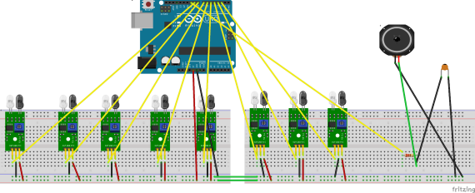

The PicoTones project utilizes IR sensors, an Arduino board, and a speaker to create an interactive instrument that produces sound when keys are touched. Here's an explanation of how it works:

● IR sensor detects the movement of fingers on the piano. When a finger is kept above the IR sensor, it senses the change in infrared light reflection and generates an electrical signal as input for the Arduino.

● The Arduino board acts as the central processing unit of the system. It receives input signals from the IR sensor and processes them to generate sound signals for the speaker. The Arduino is programmed with logic that maps the sensor input to corresponding musical notes or tones.

● The speaker is used for producing the sound output of the piano. It is connected to the Arduino through Low Pass Filter which allows only low-frequency signals. When the Arduino processes the input from the IR sensor and generates the appropriate sound signals, the speaker produces the corresponding musical notes, creating the sound of a piano.

In the program, a set of 8 digital sensors are used, connected to pins 2 to 9 to play different musical notes on a buzzer connected to pin 10. The code defines the frequencies of eight musical notes (C3, D3, E3, F3, G3, A3, B3, and C4) and stores them in an array called "freq". It also defines an array "sensorPins" to store the pins to which the sensors are connected.

In the "setup()" function, the code sets the sensor pins (2 to 9) as inputs and sets their initial state to HIGH to enable the sensors to detect LOW signals when they are triggered. It also sets the speaker pin 10 as output and sets its initial state to LOW to keep the speaker off.

In the "loop()" function, the code reads the state of each sensor using "digitalRead()" and prints the values to the serial monitor. If a sensor is triggered (reads LOW), it plays the corresponding musical note on the speaker using the "tone()" function, which takes the speaker pin, the frequency of the note, and the duration (20 milliseconds) as arguments. The frequency of the note is obtained from the "freq" array based on the index of the triggered sensor. The code loops through all the sensors and continuously checks their states to play the appropriate musical notes on the buzzer when the sensors are triggered.

Prototype Pictures

Link to f3d File: https://a360.co/40vh17y

Front View:

Top View

Isometric View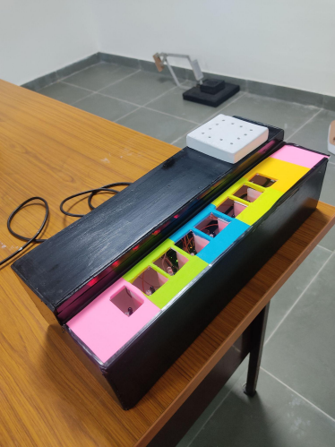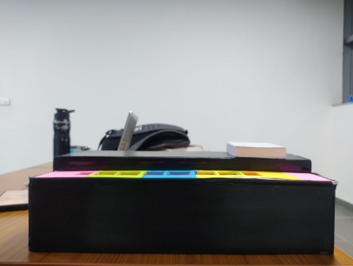

References

● Wikipedia

● Google

● Quora

● Arduino Documentation